DevNest Shared Services & Product Dependency Map (v0.9 – “current as-is”)
Owner: Platform Ops (shared)
Last Updated: October 1, 2025
Note in margin: “Mapping is 90% right; some tags are legacy.”
“This doc reflects intended architecture. Automation scopes read from inventory.yaml and may diverge in edge cases.”

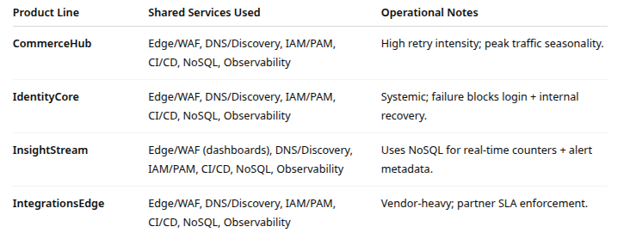

Inventory.yaml
Operational note (attached to YAML): “Inventory file is consumed by dns-refresh, cicd-scope, edge-rollout. Treat tag edits as Tier-0 changes.”
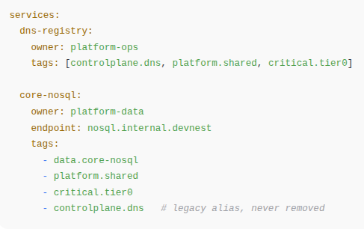

Shared-Service Tags Used by Automation

Standards Table (What Platform Ops intends)

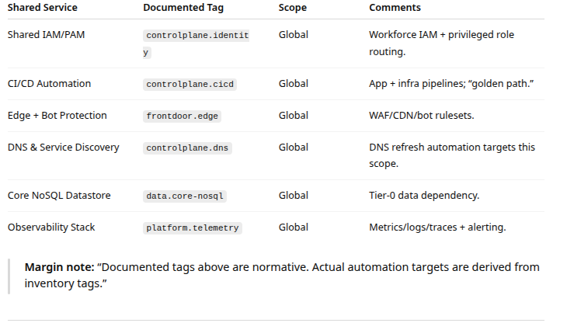

Inventory Table (What Automation actually reads)
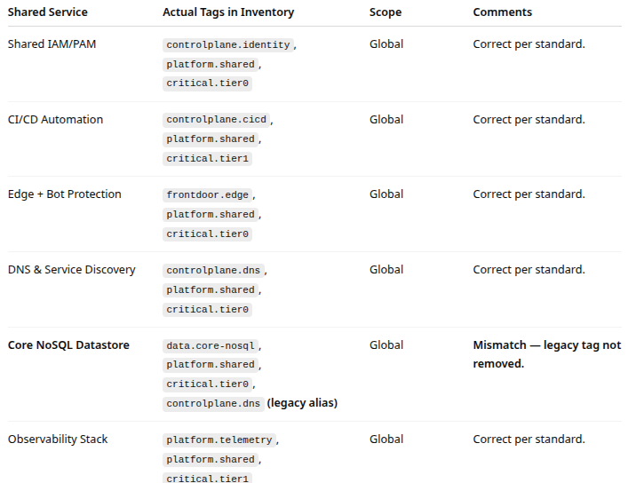
Inventory File Changelog (last 12 months)
File: inventory.yaml
Repo: platform-shared-config
Maintainers: “platform-ops@devnest” + “platform-data@devnest” (rotating)

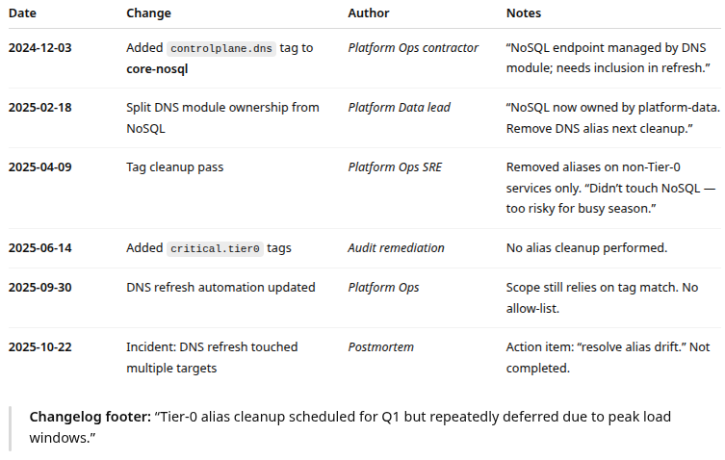

Known but Unresolved Issues
- Tier-0 scope drift
  - Tag aliasing on Tier-0 services creates hidden blast radius.
- Global automation without guardrails
  - Both CI/CD and DNS refresh rely on tags, not explicit allow-lists.
- NoSQL feeds observability
  - When NoSQL is degraded, monitoring becomes stale or unavailable.
- Edge has no hard bypass
  - Routing failure blocks status page and app access.
- IdentityCore needed for recovery tools
  - SSO outage slows incident response.

